The present assignment pertains to "design" and "implementation" of a "filesystem" (henceforth, referred as "myfs") on files provided by the underlying operating system (which can be accessed by application programs through system calls like (i) open(), (ii) read(), (iii) write, (iv) lseek, (v) close(), etc.)
Operating system allows creation of supported filesystems (fat16, fat32, vfat, ntfs, ext4, etc.) on block devices, that is, devices which are projected as "random access collection of blocks" by their device drivers. The study material in the previous page titled "Filesystem Fundamentals" highlights the layered architecture for implementation of filesystems.
In a nutshell, under the present assignment, you are supposed to write an application program, which, at one end, makes calls to (i) open(), (ii) read(), (iii) write, (iv) lseek, (v) close(), etc. to operate on OS files, and on the other hand, provide functions like (i) myopen(), (ii) myread(), (iii) mywrite, (iv) mylseek, (v) myclose(), etc., using which other programs can operate on the files of the filesystem created on myfs. Henceforth, these types of files will be called as "myfile".
Following figure explains the idea in more detail.

Please note that we can write functions, through which, an OS file can be conceived as a collection of random access blocks of fixed size. For example, a file named "dd1" can be conceived as a collection of 2048 (n = 2048) blocks, where each block is of 4096 (s = 4096) bytes.
Let, the n blocks of the file dd1 are numbered as 0 through n-1.
The file, then, can be conceived as shown in the following figure.

Note that the first 4096 Bytes (Labelled as Super Block) is kept for storing information like n (total number of blocks), s (size of each block), etc.

Subsequently, for myfs layer, we would also store ubn (number of used blocks), fbn (number of free blocks), ub (a bitmap showing which blocks are used), etc. in this block. Please note that, in ub there should be n number of bits, one bit for each block in the file (eg, dd1). An 1 (one) in a bit of ub reflects that the corresponding block is in used state. Whereas, a 0 (zero) in a bit of ub reflects that the corresponding block is in free state. The superblock also stores the block number of the block where file descriptors are saved.

Now, the contents of a myfile can spread across multiple blocks and those blocks can be "organized" in the "disk" (here the OS file, dd1, say) in various ways.

For the present assignment you adopt the organization as shown in the following figure.

Please note that at the end of each block of the file, the block number of the next block is stored with the exception that at the of the last block of the chain -1 is stored (to mark that there is no next block).
The file descriptor of a myfile stores the block number of the 1st block of the file.
Let myfs be a flat filesystem, i.e., it does not support the idea of foler/directory.
The overall organization of myfs is shown in the following figure.
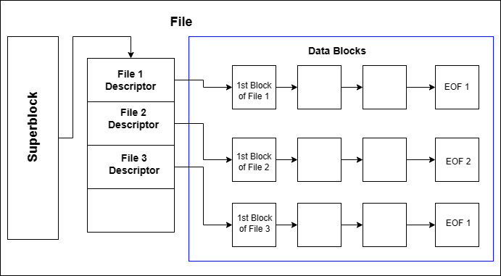

A File Descriptor would contain:
Content type | Minimum Size | Purpose
File name | 20 Characters | Stores the name of the respective myfile
First Block number | 3 Bytes | Stores the block number of the 1st block of the respective myfile
Size | 4 Bytes | Stores the size of the respective myfile
Modification Time | 32 Bytes | Stores the time of last modification in terms of epoch time

On the basis of the above model, you first write the following functions.

Please note that the parameters and return types of these functions are representative only. Make your own assumptions wrt their signature (name, parameters, return type) of these functions and how exactly they should perform their tasks.

- "int init_File_dd(const char *fname, int bsize, int bno)" that creates a file (if it does not exist) called fname of appropriate size (4096 + bsize*bno Bytes) in your folder. The function initializes the first 4096 Byes (the Super Block) putting proper values for n, s, ubn, fbn, and ub. If for some reason this function fails, it returns -1. Otherwise it returns 0.
- "int read_block(const char *fname, int bno, char *buffer)" - reads bno block number of the file fname and stores in buffer.
- "int write_block(const char *fname, int bno, char *buffer)" - writes bno block number of the file fname from buffer.
- "int get_freeblock(const char *fname" that reads the 1st 4096 Bytes (the Super Block, containing n, s, ubn, fbn, ub) from the file fname and finds and returns the block-number of the 1st free block (starting from the 0th bloc) in that file. This function sets the corresponding bit in ub and fills up the free block with 1's. ubn and fbn too are modified appropriately. On failure this function returns -1. Please note that all the modifications done by this function have to be written back to the file fname.
- "int free_block(const char *fname, int bno)" that reads the 1st 4096 Bytes (the Super Block, containing n, s, ubn, fbn, ub) from the file fname and frees the block bno, that is, resets the bit corresponding to the block bno in ub. This function fills up the block bno with 0's. ubn and fbn too are modified appropriately. On success this function returns 1. It returns 0 otherwise. Please note that all the modifications done by this function have to be written back to the file fname.
- int readblock(const char *fname, char *myfile_name, int bno, char *buffer) - reads the bnoth block of myfile_name in buffer from the file fname. This function returns 1 if successful, 0 otherwise.
- int writeblock(const char *fname, char *myfile_name, int bno, char *buffer) - writes one block of data, taking it from buffer and putting it as the data for the bnoth block of myfile_name in the file fname. If, at present, those many blocks are not present in the chain, this function will add required number of blocks in myfile_name filling them up with 0. If the given myfile_name does not exist, this function creates myfile_name. . This function returns 1 if successful, 0 otherwise.
- Write a function "int check_fs(const char *fname)" that checks the integrity of the file fname with respect to n, s, ubn, hbn, ub and the contents of the blocks. In case of any inconsistency (say, ubn+fbn ≠ n, ub does not contain ubn number of 1's, etc.), this function returns 1. It returns 0 otherwise.
The above functions are finally used by myfs while inplementing the myfs calls shown earlier in the 1st figure of this assignment.Please note that you have to write all the functions of that figure,

